Computer Graphics Lab Project
On
Village Scenario With Animated Animals
Using OpenGL

Submitted By

Ahsanur Rahman Nakib
0242310005101611

LAB PROJECT REPORT
This Report Presented in Partial Fulfillment of the course
CSE412: Computer Graphics Lab in the Department of Computer Science and

Engineering


DAFFODIL INTERNATIONAL UNIVERSITY
Dhaka, Bangladesh

21/04/2026

DECLARATION
We hereby declare that this lab project has been done by us under the supervision of Fahiba Farhin, Assistain Professor, Department of Computer Science and Engineering, Daffodil International University. We also declare that neither this project nor any part of this project has been submitted elsewhere as lab projects.

Submitted To:

Fahiba Farhin Assistant Professor
Department of Computer Science and Engineering
Daffodil International University

COURSE & PROGRAM OUTCOME
The following course have course outcomes as following:

Table 1: Course Outcome Statements
CO1 | Design and implement fundamental computer graphics primitives and algorithms to construct 2D graphical scenes for real-life visualization problems having complex engineering attribute
CO2 | Apply appropriate OpenGL programming techniques, geometric transformations, and graphics algorithms to solve complex real-world visualization problems using modern engineering tools.
CO3 | Perform effectively as an individual and as a member of a diverse team to design, document, and implement computer graphics–based projects.
CO4 | Create and present a complete computer graphics project by explaining complex engineering activities through effective reports, demonstrations, and presentations.

Mapping Course Outcome (COs) with the Teaching-Learning and Assessment Strategy

Table 2: Mapping of CO, PO, Blooms, KP and CEP
CO | POs | Teaching Learning Activities | Assessment  Strategy | Learning Domains | Knowledge  Profile | Complex  Engineering Problem | Complex Engineerin g Activities
CO1 | PO1 | TLA1  (Lab exercises) | Lab performance, Lab report | C2 | K1, K3 | EP1,EP4
CO2 | PO5 | TLA2  (Algorithm implementation) | Lab performance, Lab report | C3, C4 | K6 | EP1, EP4, EP3
CO3 | PO9 | TLA3  (Group project) | Lab project | P3, A2
CO4 | PO10 | TLA4  (Presentation & Viva) | Project & Viva | C6, P3, A2 |  |  | EA1, EA3

Table of Contents

Declaration i Course & Program Outcome ii

1 Introduction 1
1.1 Introduction 1
1.2 Motivation 1
1.3 Objectives 2
1.4 Feasibility Study 2
1.5 Gap Analysis 2
1.6 Project Outcome 2

2 System Architecture / Scene Description & Architecture 3
2.1 Requirement Analysis & Design Specification 3
2.1.1 Requirements 3
2.1.2 Sketch of project 3
2.2 Use of Modern Tools 4
2.3 Algorithm Used 5
2.4 2D Transformations Applied 5
2.5 Animation Logic 6

3 Implementation and Results 7
3.1 Implementation 7
3.2 Output 8
3.3 Discussion 11

4 Engineering Standards and Mapping 12
4.1 Impact on Society, Environment and Sustainability 12
4.1.1 Impact on Life 12
4.1.2 Impact on Society & Environment 12
4.1.3 Ethical Aspects 12
4.1.4 Sustainability Plan 12
4.2 Complex Engineering Problem 12
4.2.1 Mapping of Program Outcome 13
4.2.2 Complex Problem Solving 13
4.2.3 Engineering Activities 14

5 Conclusion 15
5.1 Summary 15
5.2 Limitation 15
5.3 Future Work 15
References 16

Chapter 1 Introduction

This chapter provides an overview of the Computer Graphics lab project, including its objectives, scope, and significance. It establishes the foundation by explaining the project's theme, visual concept, and the goals it aims to achieve through graphical modeling and real-time animation.

1.1 Introduction

This project implements an animated village scene using OpenGL (FreeGLUT) in C++, simulating a complete day-night cycle. The 1400x800 window renders a richly detailed environment including a large house with an animated window light, a big tree, two palm trees, pine trees, a flowing river with ripple animations, fish, a swimming duck, a flying bird, a cat with tail-wagging and yawning behavior, a jumping frog with water splash effects, a skipping-rope girl, sunflower and tomato garden clusters, a sky that transitions smoothly from midnight to sunrise, full daytime, and sunset, an animated sun with rotating rays, a crescent moon with a glow effect, twinkling stars, and moving clouds. The user can control time-of-day and house lighting interactively

1.2 Motivation

The primary motivation for this project is to demonstrate how foundational computer graphics concepts, such as primitive rendering, transformations, and animation loops, can be combined to produce a rich, lifelike simulation. By building every element from scratch using OpenGL primitives (GL_TRIANGLES, GL_TRIANGLE_FAN, GL_QUADS, GL_LINES), we gain deep practical insight into rasterization, coordinate systems, color interpolation, blending, and timer-based animation. The dynamic day-night system adds a layer of complexity that requires careful mathematical modeling of brightness, color lerp, and time parametrization, making it an ideal applied learning exercise.

1.3 Objectives

- Render a complete, visually appealing animated village scene using OpenGL primitives.
- Implement a smooth day-night cycle using sinusoidal brightness functions and color interpolation.
- Animate multiple autonomous entities: bird, duck, fish, frog, cat, and a skipping-rope girl.
- Apply 2D transformations (translation, rotation, scaling, reflection) throughout the scene.
- Provide real-time interactive controls for time-of-day, animation speed, and lighting.
- Implement physics-like behaviors: frog jumping with gravity, rope arc, duck bobbing, water splash.
- Demonstrate modular, function-based OpenGL design suitable for academic study.

1

1.4 Feasibility Study

The project is implemented entirely with standard OpenGL 1.x / GLUT APIs available on all desktop platforms, requiring no external game engines or shader programs. The computational load is managed through a 16ms timer callback (≈60 FPS), and all animations run on the CPU using simple .trigonometric and linear calculations. The modular function design (one function per scene object) makes the codebase maintainable and extensible. All dependencies (GL, GLU, GLUT/FreeGLUT) are freely available, confirming the project's technical and resource feasibility

1.5 Gap Analysis

Most beginner OpenGL projects present only static scenes or single animated objects. Our project bridges this gap by providing:
- A unified scene with 12+ independently animated entities running simultaneously.
- A full day-night cycle with mathematically smooth sky-color, sun-arc, moon-arc, and starvisibility transitions.
- Physics-informed animations (frog gravity, rope catenary arc, duck bobbing).
- Interactive user controls including a draggable speed slider rendered directly in OpenGL.
- Water interaction simulation: frog enters water, triggers a directional splash, then reappears at a new position.

1.6 Project Outcome

The completed project successfully renders a full animated village scene with day-night transitions, multiple autonomous characters, interactive controls, and realistic environmental effects. It demonstrates mastery of OpenGL primitive rendering, 2D transformation matrices, timer-based animation, alpha blending for glows and reflections, and modular graphics software design.

- A smooth day-night cycle with adjustable speed, accurate sky color interpolation, a dynamic sun and moon, twinkling stars, and shooting meteors.
- Over fifteen animated entities including animals, humans, plants, weather particles, and celestial objects.
- AI-driven behaviors for the girl character and sunflower cluster.
.

2

Chapter 2 System Architecture/ Scene Description & Architecture

This chapter describes the overall scene design, component architecture, and technical choices made during development. It covers the scene layout, object components, tools used, algorithms implemented, transformations applied, and the animation logic governing each entity

2.1 Requirement Analysis & Design Specification

2.1.1 Scenario Overview
The scene is a 1400x800 pixel 2D orthographic projection. The coordinate origin (0,0) is at the bottomleft. The scene is vertically divided as: sky (Y=390 to Y=800), ground (Y=0 to Y=390), and a river band (Y=73 to Y=177). The sun travels an arc from left to right during daytime; the moon takes a mirrored arc at night. Clouds drift left continuously. All color values are computed by linearly interpolating between a night palette and a day palette using the brightness scalar derived from sin(dayTime * PI).
.

2.1.2 Object Components

Object | Draw Function | Primitives Used | Animated
Sky | drawSky() | GL_QUADS (gradient) | Yes – color interpolation
Sun | drawSun() | GL_TRIANGLE_FAN, GL_LINES | Yes – arc + rotating rays
Moon | drawMoon() | GL_TRIANGLE_FAN | Yes – arc + night only
Stars (80) | drawStars() | GL_LINES (8-point  star) | Yes – twinkle via sin()
Clouds (3) | drawCloud() | GL_TRIANGLE_FAN  (circles) | Yes – horizontal drift
Ground | drawGround() | GL_QUADS | No
River | drawRiver() | GL_QUADS,  GL_LINE_STRIP | Yes – ripple waves
Fish (6) | drawFish() | GL_TRIANGLE_FAN, GL_TRIANGLES | Yes – horizontal swim
Duck | drawDuck() | GL_TRIANGLE_FAN, GL_POLYGON | Yes – swim + bob
Bird | drawBird() | GL_TRIANGLE_FAN, GL_LINES | Yes – flight + wing flap
Object | Draw Function | Primitives Used | Animated
3
Cat | drawCat() | GL_TRIANGLE_FAN, GL_LINE_STRIP | Yes – tail wag + yawn
Frog | drawFrog() | GL_TRIANGLE_FAN, GL_LINE_STRIP | Yes – jump + gravity
Girl | drawGirl() | GL_POLYGON,  GL_TRIANGLE_FAN | Yes – rope swing
House (main) | drawHouse() | GL_QUADS,  GL_TRIANGLES | Yes – window light toggle
Small  Houses (2) | drawSmallHouse() | GL_QUADS,  GL_TRIANGLES | No
Big Tree | drawBigTree() | GL_TRIANGLE_FAN, GL_QUADS | No
Palm Trees  (2) | drawPalmTrees() | GL_LINE_STRIP,  GL_TRIANGLE_FAN | No
Pine Trees  (4) | drawPineTree() | GL_TRIANGLES, GL_QUADS | No
Sunflowers | drawSunflowerCluster() | GL_TRIANGLE_FAN, GL_LINE_STRIP | Yes – stem sway
Tomato  Plant | drawTomatoPlant() | GL_TRIANGLE_FAN, GL_LINES | No
Garden Plot | drawGardenPlot() | GL_QUADS,  GL_TRIANGLE_FAN | No
Splash Effect | drawSplash() | GL_LINES,  GL_LINE_LOOP | Yes – fade out
Speed Slider | drawSpeedSlider() | GL_QUADS | Yes – draggable

2.2 Use of Modern Tools
- OpenGL / FreeGLUT – Core rendering and windowing library for 2D/3D graphics primitives.
- C++ (C++11 or later) – Primary implementation language with lambda expressions (used in drawFrog for inline eye drawing).
- GLUT Timer Callbacks – glutTimerFunc(16, update, 0) drives the animation loop at approximately 60 frames per second.
- Code::Blocks / Visual Studio / g++ – IDEs and compilers used for building and debugging the project.
4
- Alpha Blending (GL_BLEND) – Used for glow effects around the moon, house window, and water reflections.
- Math Library (math.h) – sinf(), cosf(), fabsf(), expf(), logf() used throughout for animation curves and brightness.

2.3 Algorithm Used

2.3.1 DDA Line Drawing (implicit via GL_LINES)
All line-segment rendering (whiskers, rope, tree trunk, bird legs, stem) uses OpenGL's GL_LINES primitive, which internally applies the DDA (Digital Differential Analyzer) algorithm to rasterize line segments. DDA works by incrementing one coordinate by 1 and computing the other using the slope ratio, providing smooth, anti-aliased-ready line output.

2.3.2 Midpoint Circle / Ellipse Algorithm (via GL_TRIANGLE_FAN)
All circular and elliptical objects (sun, moon, fish body, cat/frog body, eyes, flower petals, duck body, tree canopy) are drawn using GL_TRIANGLE_FAN with vertices computed as (cx + r*cos(a), cy + r*sin(a)) for a in [0, 2*PI]. This is the parametric form of the Midpoint Circle Algorithm, providing pixel-accurate circle rasterization without jagged edges. The drawCircle() and drawEllipse() helper functions encapsulate this pattern.

2.3.3 Bresenham Scan-Line (implicit in GL_QUADS / GL_TRIANGLES)
All polygon fill operations (ground, house walls, garden plot, skirt, clouds) use GL_QUADS and GL_TRIANGLES, which apply Bresenham-style scan-line fill internally within the GPU rasterizer. The drawRect() and drawTriangle() helper functions provide clean, reusable wrappers.

2.3.4 Linear Interpolation (Color Lerp)
The lerp(a, b, t) function implements the standard linear interpolation formula lerp = a + (b-a)*t. This is applied extensively in setDayNightColor() to smoothly blend between night colors and day colors for every scene element based on the brightness scalar. This produces natural transitions across the full 24-hour simulation.

2.3.5 Logarithmic Speed Mapping
The speed slider uses a logarithmic mapping between the fraction position (0–1) and the actual cycle speed, implemented via speedToFrac() and fracToSpeed(). This provides perceptually uniform speed control across the full range from 0.00005 to 0.003.

5

2.4 2D Transformations Applied
Transformation | Where Applied | OpenGL Call / Method
Translation | Bird, fish, duck, frog, clouds – move across screen each frame | Position updated via float variables; glTranslatef() in  bird/frog/duck
Rotation | Sun rays rotate continuously; rope swings by ropeAngle | glRotatef(sunRay, 0, 0, 1); sinf/cosf for rope arc
Scaling | Frog stretches horizontally when jumping (ls=1.8); mirror flip for direction | glScalef(-1,1,1) for leftfacing entities; ls multiplier on leg coords
Reflection | All left-facing animals (duck, frog, bird, fish) are mirrored | glScalef(-1, 1, 1) inside glPushMatrix/glPopMatrix
Non-uniform Scale | Ellipses drawn as scaled circles (rx ≠ ry) for duck body, fish, eyes, sun glow | drawEllipse() uses separate rx, ry parameters
Shear / Sway | Sunflower stems sway sinusoidally using swayPhase | topX = px + sway; sway = 8*sinf(swayPhase + phase)

2.5 Animation Logic
All animation is driven by a single glutTimerFunc(16, update, 0) callback that fires every 16 milliseconds (approximately 60 FPS). The update() function advances all state variables:
- dayTime: incremented by cycleSpeed each frame, wraps at 1.0. Controls the entire day-night cycle.
- sunRay: incremented by 0.4 each frame, passed to glRotatef for spinning sun rays.
- cloudX1/2/3: decremented by 0.18, 0.12, 0.22 pixels/frame respectively; wraps when offscreen left.
- birdX/Y: bird flies right, Y oscillated by 20*sin(birdX*0.02). Wing angle alternates ±18 to simulate flapping.
- duckX: bounces between screen edges at 0.5 px/frame; duckBob oscillates ±3.5 for water bobbing.
- ropeAngle / girlY: rope swings ±52 degrees; girl Y offset = -|sin(ropeAngle)| * 38 for realistic bounce.
- fishX[i]: each fish moves at its own speed (0.6 to 1.85 px/frame), wraps at screen edges.
- catTailAngle: oscillates ±0.8 radians; catYawnCountdown triggers yawn animation every 400700 frames.
- frogJumping: frog launches with random VX/VY, gravity reduces VY by 0.55/frame; detects river entry for splash.
- ripplePhase / swayPhase / starPhase: continuously incremented for river ripples, plant sway, and star twinkle.
6

Chapter 3

Implementation and Results

This chapter explains the step-by-step implementation process, key code structures, and the visual results achieved through OpenGL rendering.

3.1 Implementation

3.1.1 Initialization and Window Setup
The program initializes with glutInit(), sets GLUT_DOUBLE | GLUT_RGB display mode, creates a 1400x800 window, and calls initStars() and initFish() to randomize positions. The reshape() callback sets up a 2D orthographic projection via gluOrtho2D(0, W, 0, H), placing the origin at the bottomleft corner.

3.1.2 Rendering Pipeline
The display() function executes in layer order (painter's algorithm): sky, stars, moon, sun, clouds, ground, river, reflections, fish, duck, frog, vegetation, houses, cat, trees, bird, girl, splash, HUD. This ensures correct visual occlusion without depth buffering.

3.1.3 Day-Night Cycle Implementation
The brightness scalar is computed as: bright = max(0, sin(dayTime * PI)). At dayTime=0 (midnight) bright=0; at dayTime=0.5 (noon) bright=1. Sky colors are computed using two nested lerp calls to handle the sunrise/sunset orange blush effect. The sun arcs from (100, 420+280) to (1300, 420+280) following a sine trajectory. The moon follows an inverted phase.
float getBrightness(){ float b = sinf(dayTime * PI); return b < 0 ? 0 : b; } float lerp(float a, float b, float t){ return a + (b - a) * t; }

3.1.4 Water and Splash System
The river is drawn as a solid colored rectangle with 5 animated sine-wave ripple lines and 18 horizontal glint marks. When the frog lands in the river (frogY enters range [73,177]), splashActive is set, 8 directional splash rays are computed at random angles in the upper hemisphere, and a ring ripple expands outward. All are rendered with alpha blending and fade over ~55 frames.

3.1.5 Interactive Controls
Table 3.1: Keyboard and Mouse Controls
Input | Action
d | Set time to daytime (dayTime = 0.45)
n | Set time to midnight (dayTime = 0.0)
s | Set time to sunrise (dayTime = 0.20)
H | Toggle house interior light on/off
+ / - | Increase / decrease cycle speed by factor of 1.4
ESC | Exit the application
Drag Slider | Continuously adjust cycle speed via logarithmic mapping
7

3.2 Output
- Daytime: Bright blue sky with gradient, sun at zenith with rotating yellow rays, all scene elements in full-saturation day colors, bird in flight, sunflowers swaying, rippling river with orange sun reflection.
- Sunrise/Sunset: Sky transitions through orange-red blush; sun visible near horizon; clouds tinted warm.
- Night: Deep dark blue-black sky, 80 twinkling 8-point stars, crescent moon with soft glow, house window emitting warm amber glow (if toggled on), cat's eyes glowing green, river reflecting moonlight.
- Frog Jump: Frog stretches mid-air, enters river with animated directional splash and expanding ring ripple, then reappears on shore.

Sunrise:
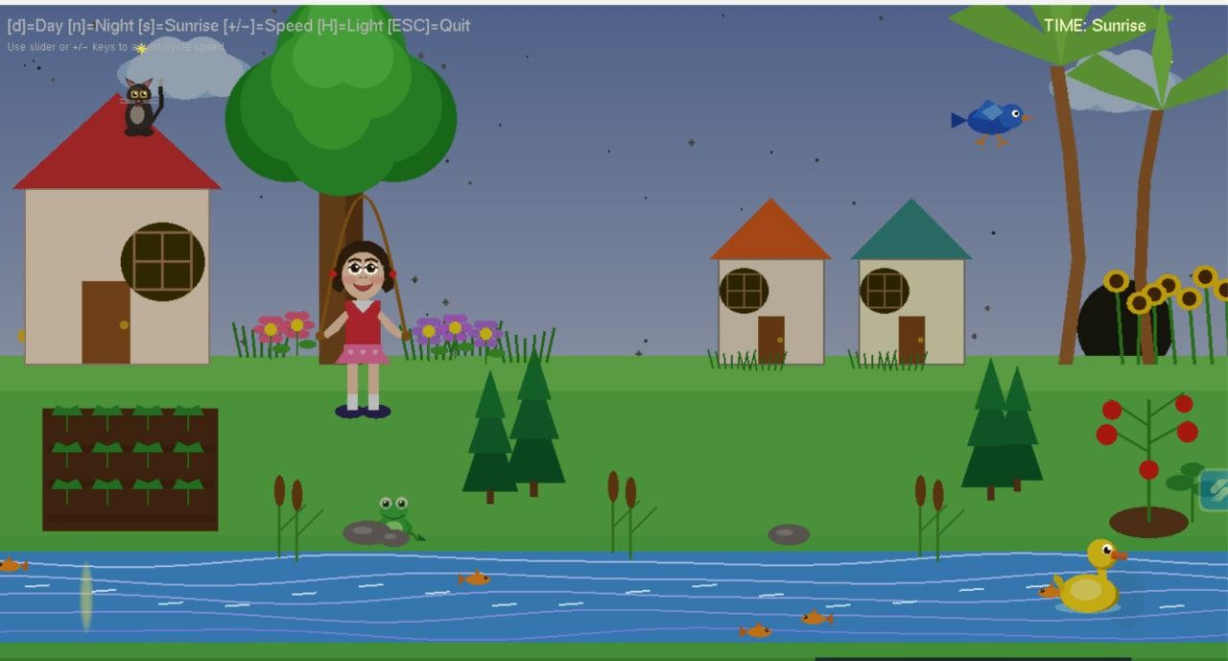

8
Daytime:
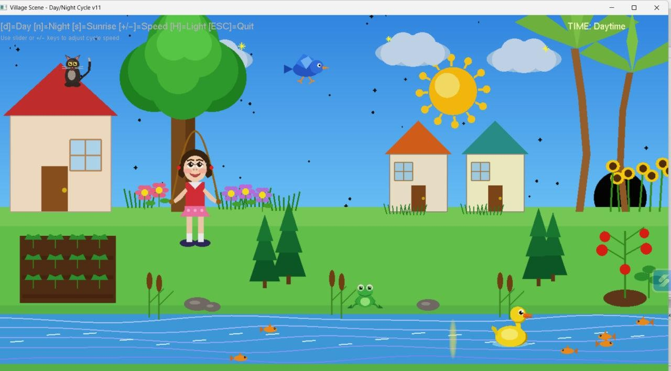

Sunset:
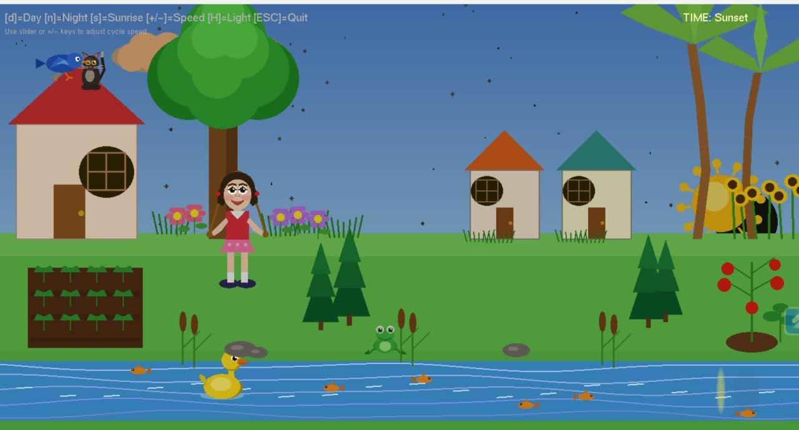

9
Midnight:

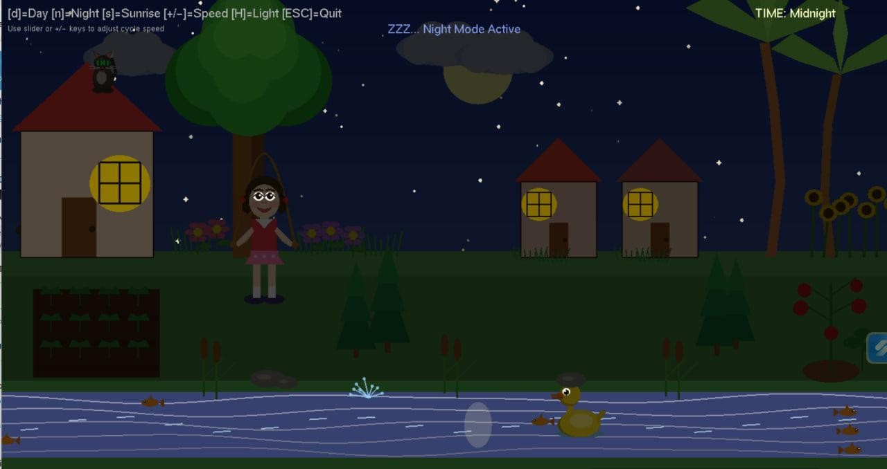

Proposed Scenario:

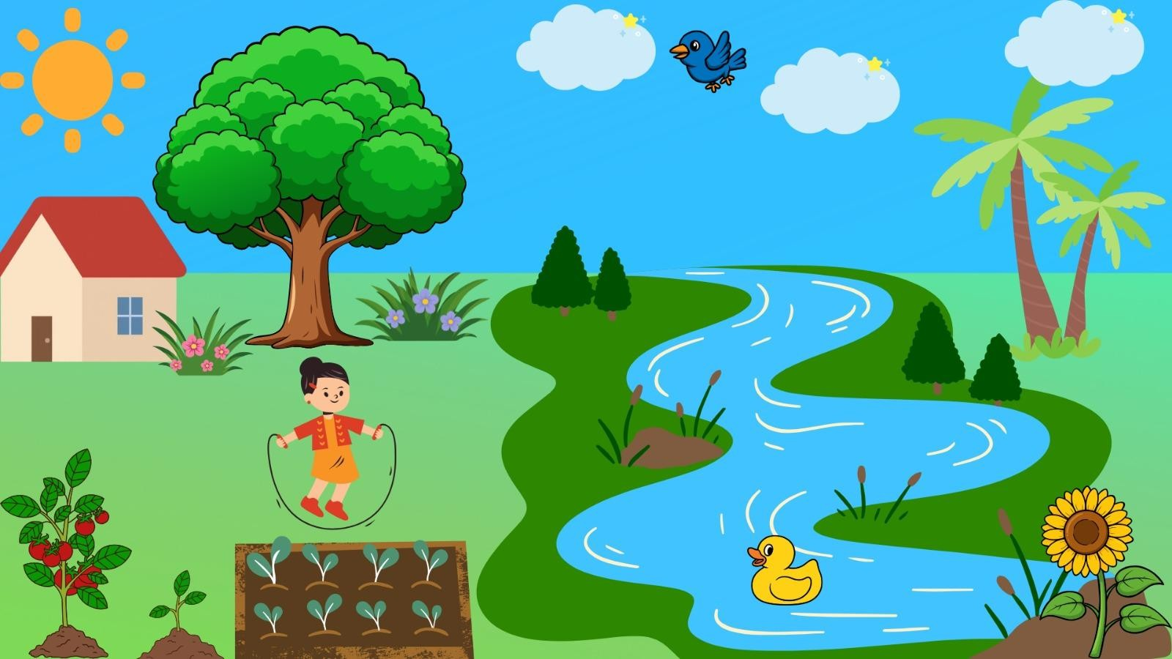

10

3.3 Discussion
The implementation successfully demonstrates the power of modular, function-based OpenGL design. Each scene element is encapsulated in its own draw function that accepts a bright parameter, ensuring correct color scaling for any time of day. The painter's algorithm ordering ensures visual correctness without depth buffering. The logarithmic speed slider provides intuitive user control. Key technical challenges overcome include: (1) computing smooth sky color for sunrise/sunset while avoiding color clamp artifacts, (2) frog boundary detection for river entry, (3) maintaining independent animation phases for 80 stars without performance loss, and (4) drawing convincing animals entirely from basic geometric primitives.

11

Chapter 4

Engineering Standards and Mapping

This chapter discusses the engineering standards followed throughout the project and maps the project activities to course and program outcomes.

4.1 Impact on Society, Environment and Sustainability

4.1.1 Impact on Life
This project enhances students' understanding of applied mathematics (trigonometry, linear interpolation, logarithmic functions) and graphics programming through hands-on implementation. The animated village scene makes abstract concepts like rasterization, coordinate transformation, and frame-based animation concrete and memorable. Skills developed directly transfer to careers in game development, UI/UX animation, scientific visualization, and simulation engineering.

4.1.2 Impact on Society & Environment
As a purely digital simulation, the project has no direct environmental footprint. The open-source tools (OpenGL, FreeGLUT, GCC) used promote accessibility and reduce software costs. The project could be adapted as an interactive educational exhibit to teach children about natural environments, animal behaviors, and the concept of day-night cycles in a museum or classroom setting, contributing positively to STEM education.

4.1.3 Ethical Aspects
All code in this project is written originally by the student team. No assets from commercial sources or unlicensed libraries have been used. OpenGL and FreeGLUT are open-source and freely available for academic use. The project contains no offensive, misleading, or culturally insensitive content. Full academic integrity has been maintained in accordance with Daffodil International University's policies.

4.1.4 Sustainability Plan
The codebase is structured for extensibility. New scene objects can be added by implementing additional draw functions following the established bright parameter convention. The animation system can be extended with more entities without architectural changes. Future versions could introduce 3D perspective, texture mapping, and GLSL shaders while preserving the same modular structure.

4.2 Complex Engineering Problem

4.2.1 Mapping of Program Outcome

12
Table 4.1: Justification of Program Outcomes

POs | Justification of Mapping (Project Perspective)
PO1 | This project applies mathematical and computational knowledge to create and transform graphical objects using OpenGL. It integrates geometry, coordinate systems, and matrix operations to solve complex visualization and animation problems in computer graphics. (PO1).
PO5 | The project incorporates modern computer graphics tools and technologies such as OpenGL, FreeGLUT, and C++ programming to ensure the application of contemporary engineering practices and visualization techniques in real-world scenarios.
PO9 | Through collaborative project work, every member was engaged in teamwork, task allocation, and documentation. (PO9).
PO1  0 | Presenting the developed computer graphics project, preparing technical reports, and communicating ideas clearly (PO10)

4.2.2 Complex Problem Solving

The following table presents the mapping of the project with the Complex Engineering Problem (CEP) attributes defined by the Washington Accord framework. The attributes that are addressed in this project are marked (✓).
Table 4.2: Mapping with complex problem solving.
EP1  Dept of  Knowledge | EP2  Range of  Conflicting  Requireme  nts | EP3  Depth of  Analysis | EP4  Familiarity of Issues | EP5  Extent of  Applicable Codes | EP6  Extent  Of  Stakeholde  r  Involveme  nt | EP7  Inter-  dependence


EP1 (Depth of Knowledge): The project requires simultaneous application of rasterization algorithms, 2D affine transformations, parametric animation, color theory, and event-driven programming – spanning multiple knowledge domains.
EP3 (Depth of Analysis): Building 12+ animated entities required careful analysis of coordinate systems, animation phase relationships, color blending ranges, and boundary detection logic (frog-river collision).
EP4 (Familiarity of Issues): The project works within the well-defined domain of OpenGL 1.x fixed-function pipeline, applying established techniques (painter's algorithm, glPushMatrix/glPopMatrix) to a novel creative problem.

13

4.2.3 Complex Engineering Activities

Table 4.3 presents the mapping of the project with the Complex Engineering Activities (CEA) attributes. The attributes relevant to this project are marked (✓).
Table 4.3: Mapping with complex engineering activities.
EA1 | EA2 | EA3 | EA4 | EA5

EA1 (Design): The project follows a systematic design process – scene layout design, coordinate system specification, object hierarchy, rendering order planning, and animation state machine design – all documented in this report.
EA3 (Innovation): The integration of a physics-informed frog jump with gravity, river entry detection, and particle-like splash effects, combined with a logarithmic-mapped interactive speed slider rendered in OpenGL, represents innovative problem-solving beyond the standard scope of introductory graphics projects.

14
Chapter 5

Conclusion

5.1 Summary
This project successfully implements a fully animated village scene simulation using OpenGL (FreeGLUT) and C++. The scene features a complete day-night cycle driven by a sinusoidal brightness model, smooth sky color transitions through sunrise and sunset, an animated sun and moon following parabolic arcs, 80 twinkling stars, 3 drifting clouds, a flowing river with animated ripples and reflections, 6 independently swimming fish, a bobbing duck, a flying bird with wing flap animation, a cat with tail-wagging and yawning behavior, a physically-simulated jumping frog with water splash effects, a skipping-rope girl with realistic rope catenary simulation, sunflower stems swaying in the breeze, and three houses with toggleable interior lighting. Interactive controls allow real-time manipulation of the time-of-day and animation speed via keyboard and a custom draggable OpenGL slider. All rendering is achieved entirely through OpenGL primitives, demonstrating mastery of circle/ellipse drawing, polygon fill, line rendering, 2D transformations, alpha blending, and modular graphics software architecture.

5.2 Limitation
- All rendering uses the fixed-function OpenGL 1.x pipeline; no GLSL shaders are used, limiting lighting realism.
- No texture mapping is applied; all surfaces are flat-colored, which reduces visual fidelity.
- The scene is strictly 2D; no depth, perspective, or 3D geometry is implemented.
- Physics simulation is simplified (no real collision detection beyond river boundary check).
- Performance relies on CPU-side animation; with many more entities, frame rate could degrade.
- No sound effects accompany scene events (e.g., splash, bird call).

5.3 Future Work
- Migrate to modern OpenGL (3.3+) with GLSL vertex and fragment shaders for per-pixel lighting and shadow mapping.
- Add texture mapping to houses, trees, and ground for photorealistic detail.
- Extend to a 3D perspective scene using glm transformations and a camera system.
- Introduce weather effects: rain particles, fog, and animated lightning.
- Add spatial audio for environmental ambience synchronized with the day-night cycle.
- Implement more complex animal AI with pathfinding, flocking (fish school behavior), and predator-prey interaction.
- Package as a cross-platform educational screensaver or interactive exhibit application.

15

References
- OpenGL Programming Guide (Red Book), 9th Edition – Dave Shreiner et al., Addison-Wesley.
- OpenGL SuperBible, 7th Edition – Graham Sellers et al., Addison-Wesley.
- FreeGLUT Project Documentation. https://freeglut.sourceforge.net/
- GeeksforGeeks OpenGL Tutorials. https://www.geeksforgeeks.org/getting-started-with-opengl/
- Hill, F. S. & Kelley, S. M. (2006). Computer Graphics Using OpenGL (3rd ed.). Pearson Prentice Hall.
- Stack Overflow – Animation and OpenGL timer discussions. https://stackoverflow.com/
- Foley, J. D., van Dam, A., Feiner, S. K., & Hughes, J. F. (1990). Computer Graphics: Principles and Practice. Addison-Wesley.

16

